**Name:- Dharan Gowda Superset id:-6387532**

**My Academy team at Cognizant want to create a dashboard containing the details of ongoing and completed cohorts. A react application is created which displays the detail of the cohorts using react component. You are assigned the task of styling these react components.**

**Step 1: Create the CSS Module**

**Create the file CohortDetails.module.css in the src/ folder:**

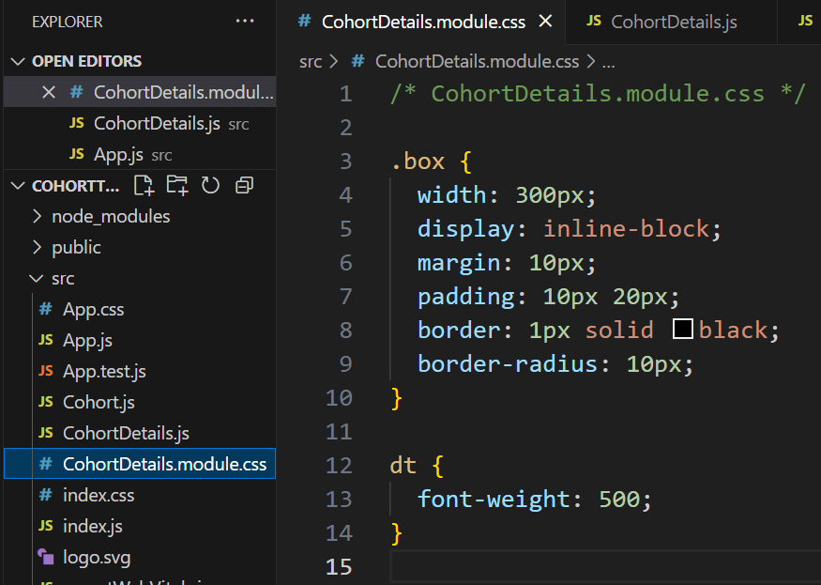

**Step 2: Modify CohortDetails.js to Use CSS Module and Conditional Color**

Update the CohortDetails.js like this:

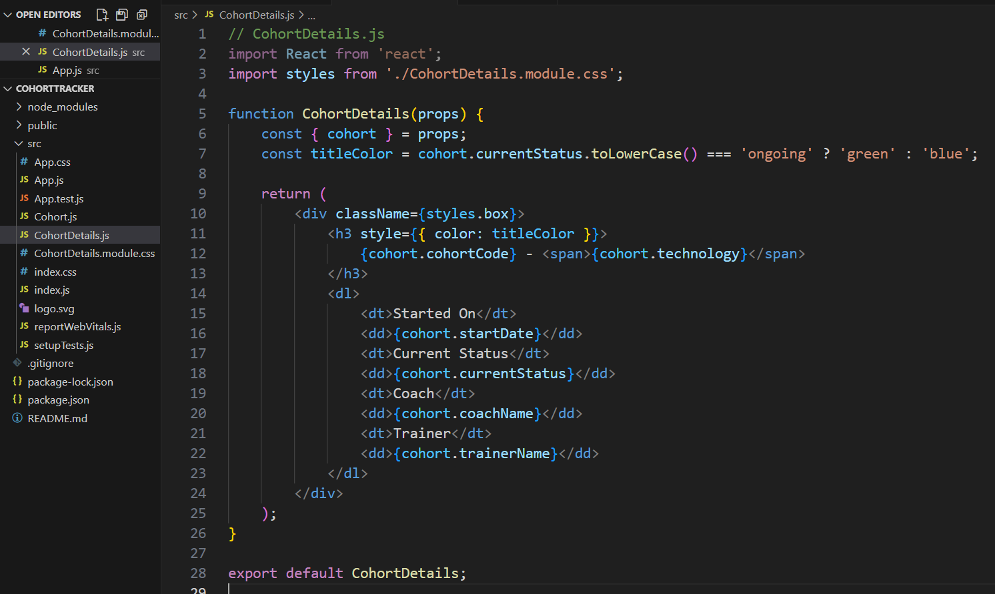

**Step 3: Update App.js to Add key for Each Item**

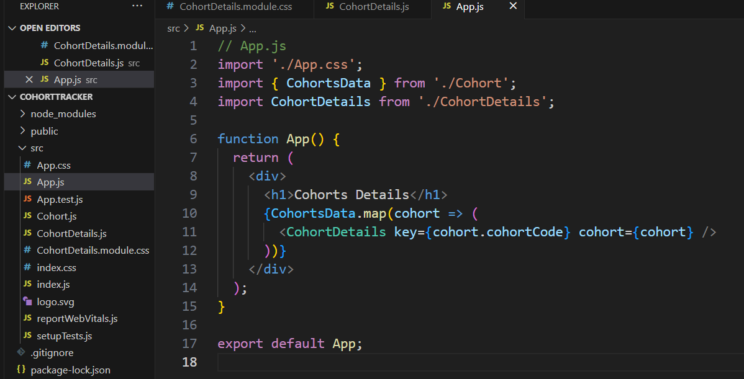

**Step 4: Run the App**

In the terminal, run:

npm start

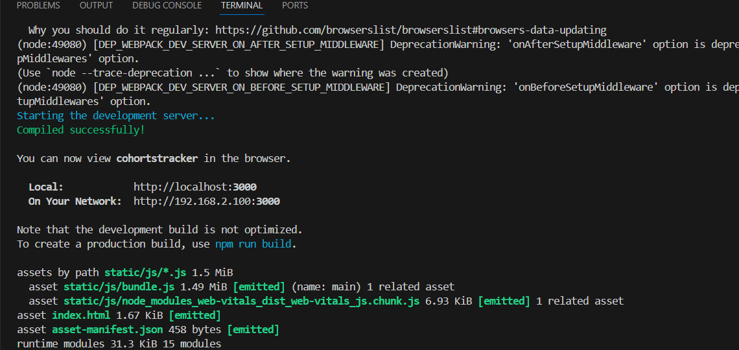

**Output at browser:-**

